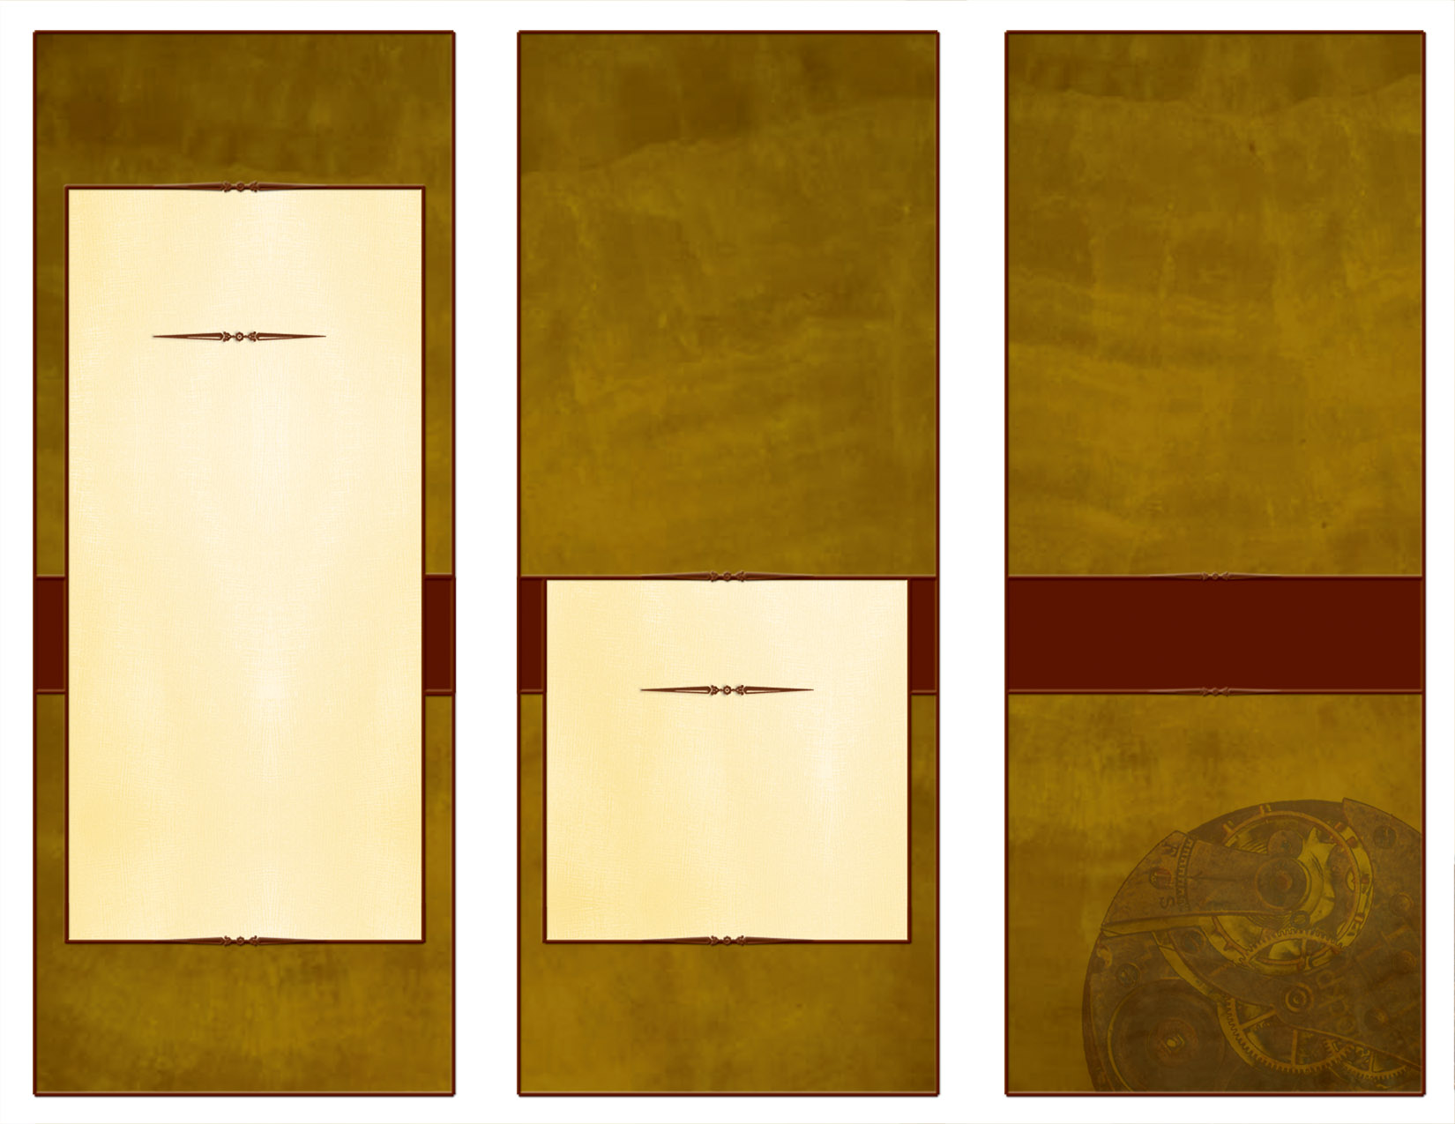<EMPTY><EMPTY>

***The deadline for nomination is***

***March 10, 2017.***

***Submit Nominations to:***

***H.B. McDaniel Foundation Awards Committee***

***Attention: Yolanda Juarez***

***5374 E. Liberty Ave***

***Fresno, CA 93727***

***or***

***E-mail***

[yobella@comcast.net](mailto:yobella@comcast.net)

***H. B. McDaniel Awards***

***2017***

***Two special counseling and guidance awards will be awarded to the outstanding group or team for 2017. These awards are established in honor of the late H.B. McDaniel, considered to be the “father of counseling and guidance in California”.***

***One award recognizes an individual who has made an outstanding contribution in the field of counseling and guidance. The second award recognizes a group or team who has developed and implemented an exemplary program in counseling and guidance.***

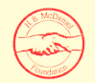



***Excellence in Counseling and Guidance***

***H. B. McDaniel Awards***

***2017***

**Delete box,   
or place a   
tag line or quote here.**

<EMPTY><EMPTY>

***Winners must be present at the Annual McDaniel Banquet at Stanford University to receive their award and be honored. The banquet will be held on***

***April 22, 2017.***

***Nominate an Individual if he/she has:***

* ***Demonstrated exceptional leadership.***
* ***Made significant contribution to the field of counseling and guidance.***
* ***Provided a unique professional***

***counseling service or has developed or directed a guidance program that has proven to be effective and serves as a model for others.***

* ***Made a contribution for a minimum of five years.***
* ***Provided leadership in the area of counselor education.***
* ***Completed outstanding research in counseling and guidance.***

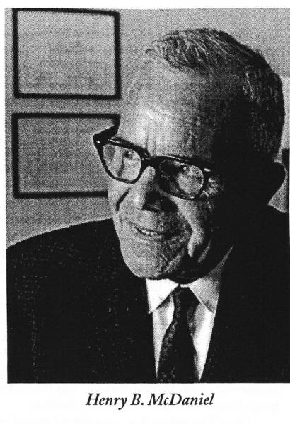

***H.B. McDaniel Group***

***Award for Outstanding Leadership***

***H.B. McDaniel Individual Award for Outstanding Leadership***

***Nominate a Group if they have:***

* ***Developed and are conducting a comprehensive model program or project.***
* ***Completed significant research resulting in a major impact in the field.***
* ***Proven program effectiveness (research-based).***

***H. B. McDaniel Awards***

***2017***

***Delete box, or add a logo, photo, or other image here. Delete box, or add a logo, photo, or other image here.***

***Delete box, or add a logo, photo, or other image here. Delete box, or add a logo, photo, or other image here.***